ASSIGNMENT
CLIENT-SERVER ARCHITECTURE
Client–Server Architecture is a system where a client (user device or application) sends a request to a server, and the server processes the request and sends a response back to the client.
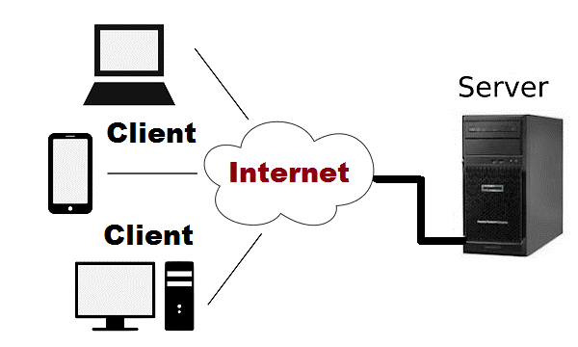
Explanation:
Client: The client is the user device, like a computer or mobile. A web browser acts as a client. It sends requests and shows the output to the user.
Server: The server is a powerful computer that stores websites, data, and programs. It receives requests from the client, processes them, and sends responses.
How it works:
- The client sends a request to the server.
- The server processes the request.
- The server sends a response back to the client.
- The client displays the result.

What happens when we open a website:
- You open a browser and type the website name (URL).
- The browser finds the website’s server address using DNS.
- The browser sends a request to the server.
- The server receives the request and processes it.
- The server sends a response.
- The browser reads the response and shows the website on the screen.

